SPRING Technologies will demonstrate unified and software all-in-one platform NCSIMUL SOLUTIONS, at METAV 2016

Streamline your CNC programming with the new module NCSIMUL CAM

Paris –December 15, 2015
SPRING Technologies, worldwide leader in delivering dedicated CNC software solutions to enable the optimal use of CNC machines, will be demonstrating its innovative software platform NCSIMUL SOLUTIONS at METAV 2016, the international tradeshow for metalworking technologies, which will take place at Düsseldorf in Germany from February 23rd to 27th 2016. The focal point of SPRING Technologies’ presentation at METAV will be its latest module, NCSIMUL CAM. This cutting-edge all-in-one CNC programming solution optimizes existing CAM process and enables a simplified, bidirectional End-to-End-Machining Process.
As an innovative example for the realization of Industry 4.0, SPRING Technologies will showcase its NCSIMUL SOLUTIONS platform with the new NCSIMUL CAM, on its own booth hall 14 - D122, as well as at the Innovation Park of Industry Arena – hall 14 booth A107.
The software all-in-one platform provides a complete, integrated control of the entire end-to-end machining process in real time, including NC programming, machine simulation, optimization, tool management, program transfer and real-time monitoring of the machine status.

With NCSIMUL CAM, CNC machines can be run 100% collision-free from the first second – without the need of any external post-processor. In just a few clicks, NCSIMUL CAM generates new self-verified and self-optimized CNC programs, whatever the type and complexity of the machine, its kinematics and the type of controller.
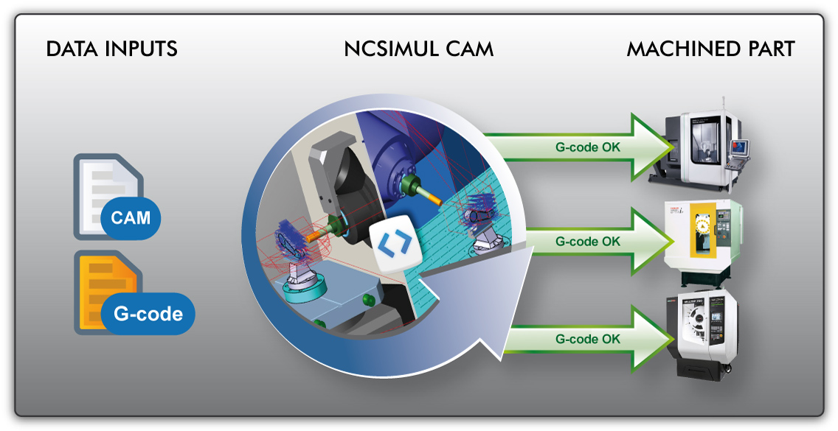
In this way, manufacturers can quickly adapt their programs to the latest available resources, re-tooling or needs for maintenance. NCSIMUL CAM can be used in one click to reprogram the machining operation for another machine and automatically reconfigure the tool magazine, for a complete flexibility of the production process.
This unique concept does not only simplify and streamline the entire digital production process, it also enables users to control costs and production times, while increasing CNC machine uptime and winning the battle of flexibility.
The SPRING Technologies team is looking forward to live demonstrations as well as an inspiring conversations with the visitors of METAV.

Where? Messe Düsseldorf, SPRING booth- hall 14 booth D122 – and demonstration point at Innovation Park of Industry Arena - hall 14 booth A107.

When? February 23rd-27th 2016

ABOUT SPRING TECHNOLOGIES
SPRING Technologies develops software solutions designed to optimize manufacturing companies' CNC machines to reduce costs and maximize productivity.
Its product NCSIMUL SOLUTIONS® provides a complete and integrated mastery of the production process from Methods departments to Workshop including NC programming, machining simulation, cutting tool management, CNC program management and real time machine status monitoring.
This unique approach simplifies the digital chain and provides needed tools and flexibility for the implementation of automated factories.
Based in France, Germany, PR China and the USA, the company was founded in 1983 and collaborates with manufacturers in aerospace and defense, transportation, energy, industrial equipment and medical devices, using CAM software’s such as CATIA, NX, CREO, TOPSOLIDCAM, MASTERCAM…. Through its global network of resellers, SPRING supports its customers all over the world.
For more information, visit: www.ncsimul.com

NCEXPERIENCE, NCSIMUL, Optitool and NCdoc are registered trademarks of SPRING Technologies.
Press Contacts:
Philippe Solignac - Corporate Marketing Director, HQ - psolignac@ncsimul.com
Patrick Schulze - Wordfinder Ltd. & Co. KG - ps@wordfinderpr.com

